Free the Drugs
Front Range Community College
[NAME]

INTRODUCTION/SUMMARY:
War is no way to handle addiction. The expression, “you want what you cannot have”, has been around for many decades, and seems to continue to be true. Therefore, declaring war on drugs is a sure way to increase drug use. The drug epidemic is a huge problem in America, and yet there seems to be no end in sight. It seems that current and past administrations have not been able to create a well thought out way to lower the drug abuse rates in America. Instead, both users and addicts are just stuck in the vicious cycles of addiction until and unless they have the resources to be able to get treatment necessary to break free. For the purpose of this paper, I will be referring to both as just users for simplification. The antiquated and archaic idea that placing users into incarceration as a form of rehabilitation has yet to produce viable evidence that it is successful in doing anything other than filling our prisons with typically nonviolent offenders. Unfortunately, it is not that simple. Once they are in prison they have a record and once they get out of prison they will have a harder time finding jobs because of their record and usually just return to drug use, and in a lot of instances resort back to the lifestyle that put them in prison to begin with. A user is more accepted if they are seeking treatment instead of getting a criminal record, which makes it hard for the user to find and have a good and clean support group, as well as a support network outside of these groups. Typically, when the user is in prison they have access to the same street drugs that they had out of prison. Also, in prison, most states do not have any treatment options for the user, while incarcerated, to be able to safely wean off drugs that have a physical dependency, and can altogether be dangerous as well as life threatening. At the very least, quitting without tapering down the use of the drug is said to be very painful. However, the epidemic seems to just be getting worse and worse, so something does need to be done and someone needs to come up with some type of a plan that will finally work. I can be that someone and I want to be that someone, who can step forward and help with a workable plan. I believe that my plan is functional and has real possibility, but the challenge will be to put into process. Congress must be willing to go against the social norms of the way drug use and abuse are looked at and then take the lead to show the country and the world how this reform of rehabilitation is for the better and can work. One must stay open minded and be willing to listen and understand this new idea. It will help lower drug addiction and in turn also help all of society. My plan in its simplest for is to legalize all drugs, but it is in fact much more complex than that.
(BACKGROUND/PROBLEM)
The current drug use and abuse issues and problems in America are continuing to rise and so far it seems uncontainable. Recently, the President of the United States, Donald J. Trump, has addressed the current drug epidemic and he focused mostly on attacking the opiate epidemic. The United States Department of Health and Human Resource published an informative poster shown below.
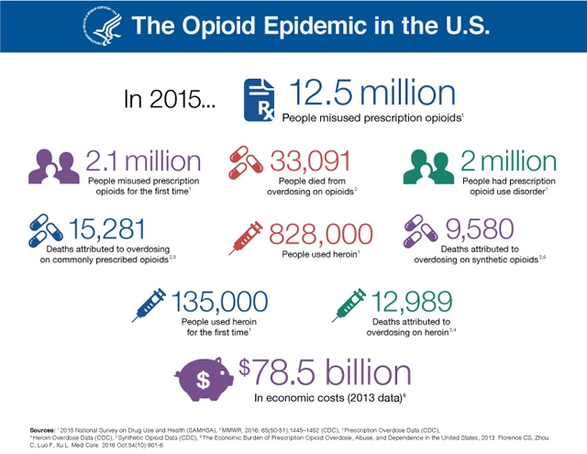
The poster shows that 12.5 million people misused opiate prescription drugs and 828,000 people used heroin in 2015(hhs.gov 2017). In 2014 research showed that 21.5 million people, ages 12 and up, have suffered from a substance abuse disorder just in the United States (Drugabuse.org). Addiction is costing society around 740 billion dollars. Society’s taxes go to pay for the user’s health care, prison time, lawyers, and anything else provided by the government that the user may need. The United States is not the only country currently fighting the epidemic; however some countries have already fought it and have had successful results. Portugal is one of the countries that already had to deal with a drug epidemic. According ______, who sat down for an interview with NPR in ___ in the 90’s to the early 2000’s Portugal had the highest drug problem that the government has seen yet. Their country was suffering from opiate addiction brought from their revolution in 1974 where they overthrew their government at the time. The people had newly found freedom and with that newly found drugs. The new government knew that something had to be done, so in 2001 they decriminalized all illegal drugs. When someone is either overdosing or acting out in public because they are high police still arrest them and take them to court. But, once the person is in the court room the judge now is reprimanding their erratic behavior and not the drug use. So, the user is now given a misdemeanor or given a fine for their behavior and then is given a mandatory referral for treatment. However, this does not mean that drug dealers can now get away with distributing the drugs. In fact, anyone who has more than a 10 day supply would be treated as a drug dealer and will still be punished with prison time. This has shown helpful for Portugal in many different ways. Their death by overdose rate is now down to three deaths per million people. This new policy has also brought down drug related HIV down by 95% (NPR). This shows that not only was there an improvement with overdose, but also an improvement in addiction because people are able to openly seek help without a stigma and no longer have a hindering criminal background. However, in America deaths from overdosing has grown. According to the New York Times just in Akron, Ohio alone there were an estimated 59,000 overdose related deaths in 2016 (NYTIMES). Below is a graph of the increase in overdose deaths from 2000 to 2016 provided by DRUGABUSE.
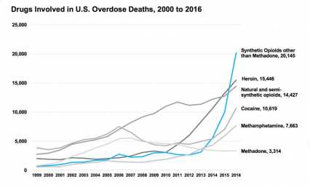
As shown in the figure above the total drug overdose deaths have continued to rise and a spike occurred in 2012 and since then the growth has continued. It is estimated that there was over 64,000 deaths in total for the United States due to overdose in 2016 (drugabuse). This trend needs to start turning around the abuse needs to decrease. It is time for the government to step in and change the way addicts get help.
(SOLUTION)
The best way to lower drug use, drug related crimes, and the spread of disease is to change the way drug addicts are treated in the criminal system. First, all illegal drugs must be decriminalized for addicts. Drug dealers are anyone who has more than one weeks supply on their person will be charged with possession of that drug and attempt to distribute the drug. Drug addicts will still be taken into custody when found, but the court system will be set-up differently for them. If the addict was just taken in for drug possession or was saved from overdosing then they will receive no jail time, but instead be given a fine to pay and then must attend mandatory rehabilitation and get treatment for their addiction. This will help the person get sober and stay sober both safely and with a support group. However, if the user was also picked up for committing a crime they will be treated differently. If it is their first time offense then they will get a “get out of jail free card” and be treated as if they were just in court for drug possession. If the addict re-offends then they will be charged with whatever crimes they have committed and will go to jail. This way the addict does not just get to openly re-offend and do whatever they want because they think they have immunity, but give them a chance to get clean and restart their lives. Addicts that are given the proper help are much more likely to succeed then an addict that is just thrown into jail. With this method the addict will still be able to obtain a job due to the fact that their record will be clean. The addict will no longer receive a felony, which means they will have more job opportunities. The addict having a job will keep them busy and hopefully keep them off the streets. The addict will stop their drug use making quitting easier, they will have access the professional help, and they will not be surrounded by drugs in the a prison. Decriminalization of illegal drugs will also help bring down drug related crimes because the addicts will be able to get better and will not have to turn back to crime because there will be no criminal record. Drug related disease spread will also go down because the addicts will have access to clean needles, so no one is sharing and as time goes on the drug use in America will go down. In order to put this plan into place all that must be done is the re-arrangement of the society’s tax dollars. Currently their tax dollars pays for an addicts time in prison, any medical attention they may need while in prison, the public defender, and the police to arrest them. Instead the tax payers can help pay for the addict to get arrested and to get treatment. It will be cheaper for the tax payers to help a user become clean once then it will be to continue to fund them going to prison over and over again. Then tax payer dollars can be used more efficiently and the prison system will not be so over flown with addicts. This is a solution to America’s current drug epidemic and it will work.
(CONCLUSION)
This solution has a very good chance of succeeding with the help of the American people and congress. In order for this to work the stigma must be changed about addicts. Everyone runs into problems here and there, but if you are just willing to help them then they can get back up on their feet and become a functioning member of society once again. Once society becomes more accepting of addicts they will be able to get themselves better without feeling ashamed and take the help they are given. Overall this program will help millions. If congress accepts my solution and puts it in place I believe that Americas drug problems will start to disappear. Be open and give hope then these will have a fighting chance.
Conclusion IS STILL UNDER CONSTRUCTION! GOING OUT OF TOWN AND NEED TO TURN THIS IN!

(WORK CITED)
Katel, P. (2006, June 2). War on drugs. CQ Researcher, 16, 481-504. Retrieved from http://library.cqpress.com/
Friedman, J. (2014, May 2). Treating addiction. CQ Researcher, 24, 385-408. Retrieved from http://library.cqpress.com/
Cooper, M. H. (2000, July 28). Drug-policy debate. CQ Researcher, 10, 593-624. Retrieved from http://library.cqpress.com
https://www.drugabuse.gov/related-topics/trends-statistics/overdose-death-rates
http://www.npr.org/sections/parallels/2017/04/18/524380027/in-portugal-drug-use-is-treated-as-a-medical-issue-not-a-crime
https://americanaddictioncenters.org/rehab-guide/addiction-statistics/
https://www.nytimes.com/interactive/2017/06/05/upshot/opioid-epidemic-drug-overdose-deaths-are-rising-faster-than-ever.html
https://www.hhs.gov/opioids/about-the-epidemic/index.html

